**CMP 409 REPORT**

**Artificial Intelligence**

**TOPIC: VISUAL RECOGNITIOn**

**GROUP MEMBERS**

1. Sunday Sharon BHU/20/04/05/0001
2. Shuaibu Usman Promise BHU/20/04/05/0002
3. Idoko Benard BHU/20/04/05/0003
4. Esa James Oche BHU/20/04/05/0005
5. Ukwu Chimaroke Favour BHU/20/04/05/0006
6. Akang Stephanie Etimbuk BHU/20/04/05/0007
7. Kankara Trinity Lydia BHU/20/04/05/0008
8. Goong Karl-Mom Joshua BHU/20/04/05/0009
9. Chukwu Daniel Nonso BHU/20/04/05/0010
10. DANJUMA KUYET DIVINE BHU/20/04/05/0011

**1. Introduction/Background**

The field of visual recognition in artificial intelligence (AI) focuses on enabling machines to perceive and understand the visual world similar to humans. This report explores various algorithms used in visual recognition, including Convolutional Neural Networks (CNN), Random Forest, Support Vector Machines (SVM), and K Nearest Neighbor (KNN).

CNNs are deep learning algorithms widely used for analyzing visual data such as images and videos. They excel in tasks like image classification, object detection, facial recognition, and image segmentation. CNNs automatically extract relevant features from visual data by recognizing different layers of details, from simple elements like lines and shapes to more complex objects.

The process of CNN involves breaking down images into smaller parts, recognizing patterns in those parts, and combining these features to understand more complex shapes or objects. CNNs use convolutional layers, pooling layers, and fully connected layers to process images and make predictions. They are trained by comparing their predictions to the correct answers and adjusting their settings to improve accuracy.

Image classification is a vital task in visual recognition, involving categorizing or labeling images into predefined classes or categories. The report includes a code snippet that visualizes a set of training images with their respective class labels. The code utilizes a subset of the original dataset for quicker experimentation and prototyping.

Random Forest is an ensemble learning method used for classification and regression tasks. It constructs multiple decision trees during training and outputs the class or mean prediction of the individual trees. Random forests are favored in visual recognition due to their robustness against overfitting and their ability to handle high-dimensional data.

Support Vector Machines (SVM) is a powerful tool in machine learning, particularly for tasks like image classification. SVM learns to draw boundaries between different classes by finding the best way to draw a hyperplane for accurate classification. It excels in high-dimensional visual data representation and is versatile in handling complex datasets.

The K Nearest Neighbor (KNN) algorithm is a non-parametric, supervised learning classifier. It makes classifications or predictions based on the proximity of data points. KNN is commonly used in face recognition, where it classifies data points based on the majority of their nearest neighbors.

While these algorithms have their advantages, they also face challenges. KNN, for example, can be computationally expensive, slow, and memory-intensive. It is also susceptible to the curse of dimensionality, where the performance degrades as the number of dimensions increases. Understanding these algorithms and their applications in visual recognition is crucial for developing accurate and efficient AI systems capable of analyzing visual data.

**2. Problem**

The problem addressed in visual recognition is to develop AI systems that can accurately analyze, interpret, and categorize visual data. This includes tasks such as image classification, object detection, facial recognition, and image segmentation. The goal is to create algorithms and models that can understand the content and context of visual information, enabling machines to make informed decisions based on visual input.

**Algorithms Used in Visual Recognition**

1. **Convolutional Neural Networks (CNNs):**

CNNs are a class of deep learning algorithms that have revolutionized visual recognition tasks. They excel at tasks like image classification, object detection, and image segmentation. CNNs automatically learn to recognize and extract features from visual data by analyzing different layers of details, starting from simple features like edges and shapes and progressing to complex objects. CNNs consist of convolutional layers, pooling layers, and fully connected layers.

1. **Random Forest:**

Random Forest is an ensemble learning method used for classification and regression tasks. It constructs multiple decision trees during the training phase and combines their predictions to make accurate classifications. Random Forests are effective in visual recognition due to their ability to handle high-dimensional data, such as image pixels, and their robustness against overfitting. They identify informative features from large datasets and leverage the ensemble approach to improve accuracy.

1. **Support Vector Machines (SVM):**

SVM is a powerful algorithm in machine learning, particularly for image classification tasks. SVM learns to draw optimal decision boundaries between different classes in a dataset, enabling accurate classification. SVM is highly versatile and excels in high-dimensional data representation, making it suitable for visual recognition. It finds optimal decision boundaries, leading to precise and accurate classifications.

1. **K Nearest Neighbor (KNN):**

KNN is a non-parametric, supervised learning algorithm used for classification tasks in visual recognition. It operates on the assumption that similar data points are located near each other. In face recognition, KNN is a popular algorithm that locates the nearest neighbors of a data point and classifies it based on the majority of its neighbors. KNN can make highly accurate predictions and is suitable for applications that require high accuracy. However, it has challenges such as computational expense, slow speed, memory and storage requirements, distance metric selection, and susceptibility to the curse of dimensionality.

**3. Objectives/Goals**

1. **Objectives**

**Accurate Image Classification:** One of the main objectives of visual recognition is to develop models that can accurately classify or label images into different predefined classes or categories. The goal is to train models that can automatically analyze the features of an image and assign it to the correct class.

**Object Detection:** Another objective is to enable machines to detect and locate objects within images or videos. Object detection algorithms aim to identify and localize specific objects of interest, allowing for various applications such as autonomous vehicles, surveillance systems, and augmented reality.

**Facial Recognition:** Visual recognition also focuses on achieving accurate facial recognition, allowing machines to identify and verify individuals based on their facial features. This objective has applications in security systems, access control, and personalization.

**Image Segmentation:** Image segmentation is the process of dividing an image into meaningful regions or segments. The objective is to accurately separate different objects or regions within an image, enabling more detailed analysis and understanding of visual content.

1. **Goals:**

**Develop Robust and Accurate Models:** The primary goal of visual recognition is to develop robust and accurate models that can understand and analyze visual data with high precision. The algorithms used, such as CNN, Random Forest, SVM, and KNN, are designed to extract relevant features, identify patterns, and make accurate predictions.

**Handle High-Dimensional Data:** Visual data, such as images and videos, often have high-dimensional representations, with each pixel acting as a dimension. The goal is to develop algorithms and models, like Random Forest and SVM, that can handle and process this high-dimensional data effectively, ensuring accurate and efficient analysis.

**Generalize from Visual Patterns:** Visual recognition aims to develop models that can generalize from visual patterns and make accurate predictions on unseen data. By training models on diverse datasets and using techniques like ensemble learning (Random Forest), the goal is to reduce overfitting and improve the model's ability to generalize.

**Improve Efficiency and Speed:** While accuracy is crucial, visual recognition also focuses on improving the efficiency and speed of algorithms. Techniques like optimizing CNN architectures, feature extraction, and parallel processing are employed to achieve real-time or near-real-time performance.

**Address Challenges:** Visual recognition faces challenges such as computational expense, slow speed, memory and storage requirements, and the curse of dimensionality (KNN). The goal is to address these challenges through algorithmic improvements, hardware advancements, and optimized implementations.

**4. Method**

1. **Convolutional Neural Networks (CNN):**

Convolutional Neural Networks (CNN) have revolutionized visual recognition tasks, particularly in image classification and object detection. CNNs are deep learning models inspired by the human visual system. They consist of multiple layers, including convolutional layers, pooling layers, and fully connected layers.

**Convolutional Layers:** These layers apply filters to input images, extracting relevant features by performing convolutions. The filters capture edges, textures, and other visual patterns.

**Pooling Layers:** Pooling layers reduce the spatial dimensions of feature maps while preserving important information. They help to extract the most salient features from the input.

**Fully Connected Layers:** Fully connected layers connect the extracted features to the output layer for classification or regression. They perform high-level reasoning and decision-making based on the learned features.

CNNs excel at automatically learning hierarchical representations from raw visual data, allowing them to capture complex patterns and relationships between different objects or regions within images.

1. **Random Forest:**

Random Forest is an ensemble learning method that combines multiple decision trees to make predictions. It is widely used in visual recognition tasks, especially for image classification and object detection.

**Decision Trees:** Random Forest is built by training multiple decision trees, where each tree independently learns from different subsets of the training data and features.

**Feature Importance:** Random Forest measures the importance of different features in the training data, enabling it to select the most informative features for classification or regression.

**Ensemble Approach:** By combining the predictions of multiple decision trees, Random Forest reduces overfitting and improves the accuracy and robustness of visual recognition models.

Random Forest is particularly effective when handling high-dimensional visual data, such as images, and can handle a large number of features while maintaining good performance.

1. **Support Vector Machines (SVM):**

Support Vector Machines (SVM) are powerful algorithms used for classification, including visual recognition tasks. SVM aims to find an optimal decision boundary that maximizes the margin between different classes.

**Kernel Functions:** SVM employs kernel functions to transform the input data into a higher-dimensional feature space, where it becomes easier to find a linear decision boundary.

**Margin Maximization:** SVM identifies the decision boundary that maximizes the margin between different classes, aiming for better generalization and robustness.

**Non-linear Decision Boundaries:** By using kernel functions, SVM can handle non-linear decision boundaries, making it versatile in various visual recognition applications.

SVM is effective in handling high-dimensional visual data and is known for its ability to draw optimal decision boundaries, leading to precise and accurate classifications.

1. **K Nearest Neighbor (KNN):**

K Nearest Neighbor (KNN) is a non-parametric, supervised learning algorithm used for classification and regression. It operates based on the assumption that similar data points are located near each other in the feature space.

**Nearest Neighbor Classification:** KNN classifies data points based on their proximity to the nearest neighbors in the training dataset. The class label of a data point is determined by the majority vote of its k nearest neighbors.

**Distance Metrics:** KNN uses distance metrics, such as Euclidean distance or Manhattan distance, to measure the similarity between data points.

**Curse of Dimensionality:** KNN is susceptible to the curse of dimensionality, where the effectiveness of distance metrics decreases as the number of dimensions increases. This can lead to computational expense and slower speed.

**5. Results**

The results section of this report focuses on demonstrating the capabilities of each algorithm through code snippets and examples. It includes visualizations of training images with their respective class labels and explains the processes involved in training and testing the models.

1. For CNN, the results showcase how the algorithm breaks down images into smaller parts, recognizes different features, and combines them to understand more complex shapes or objects.

Screenshots:

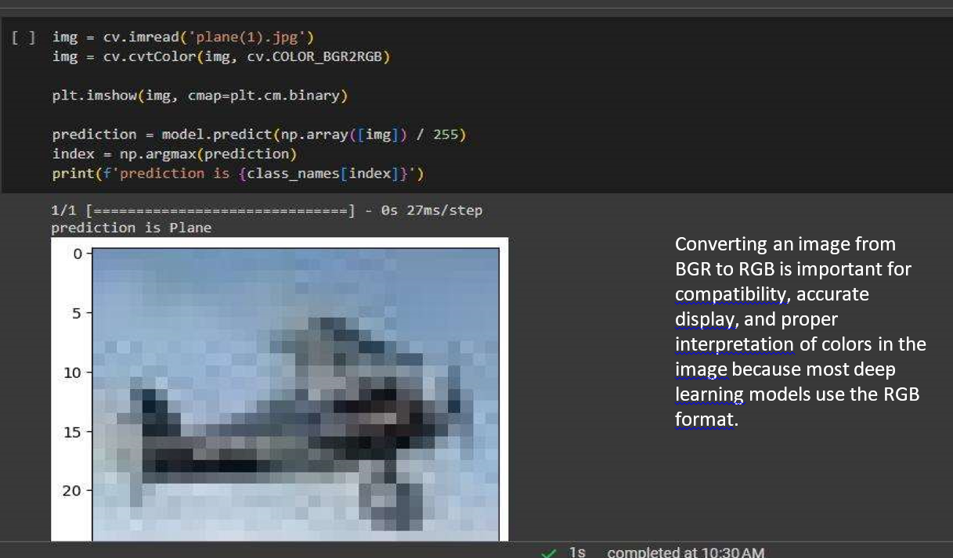

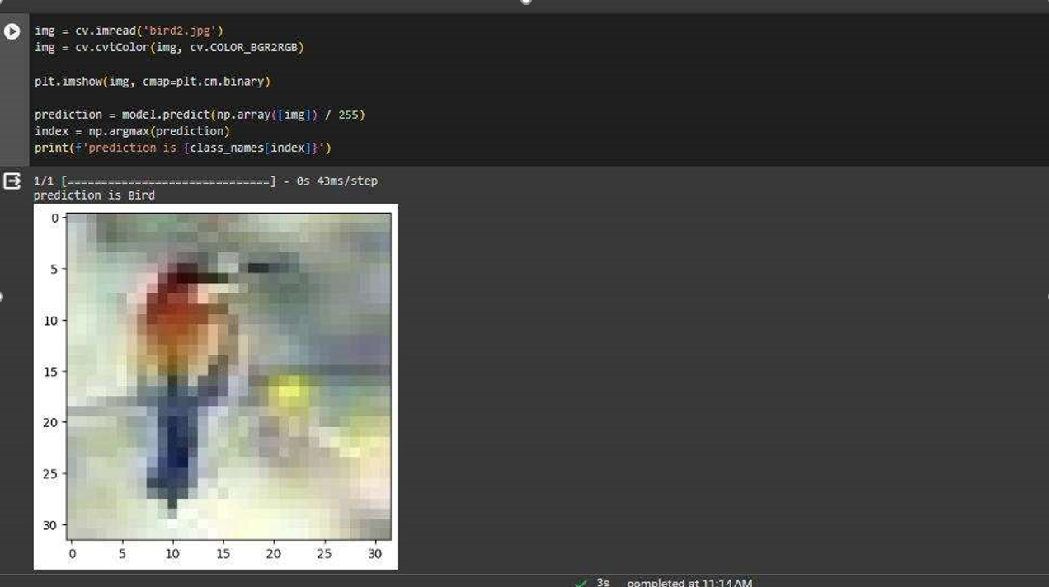 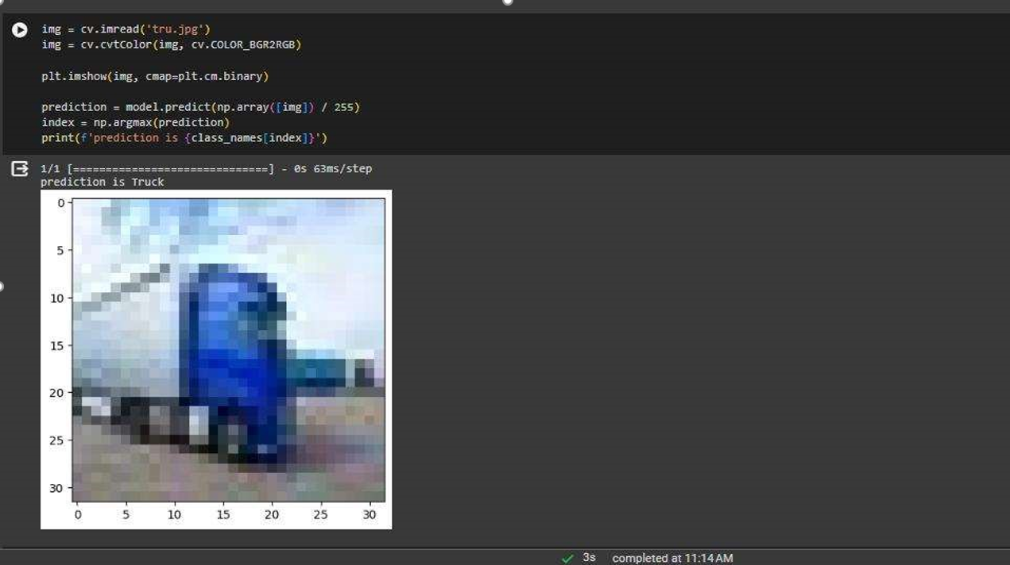

1. For Random Forest, the results highlight how the algorithm constructs multiple decision trees, averages out biases, and achieves accurate classifications by combining the results of individual trees.

Screenshots:







1. For SVM, the results demonstrate how the algorithm learns to draw optimal decision boundaries between different classes, leading to precise and accurate classifications.

Screenshots:



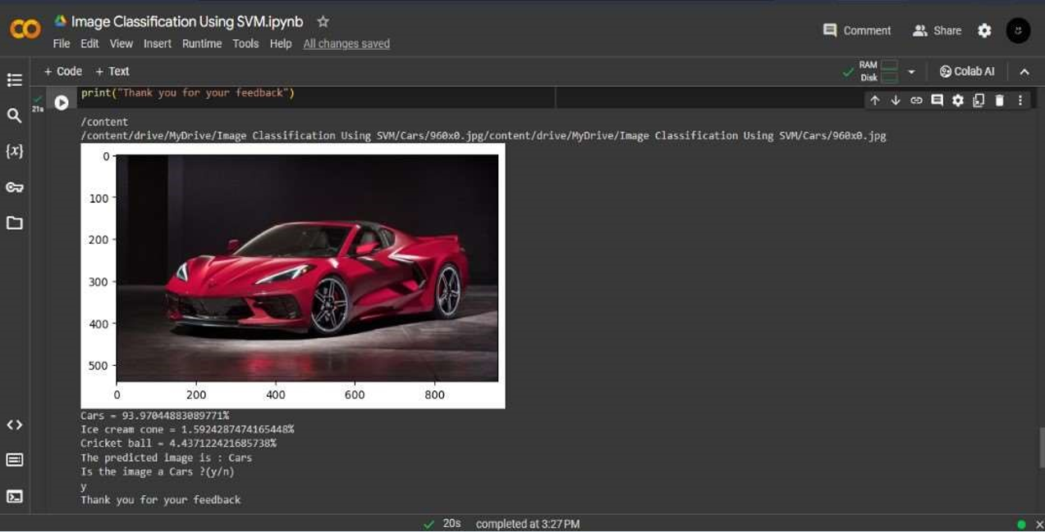

1. For KNN, the results explain how the algorithm locates the nearest neighbors of a data point and classifies it based on the majority of its neighbors, making it suitable for face recognition and classification tasks.

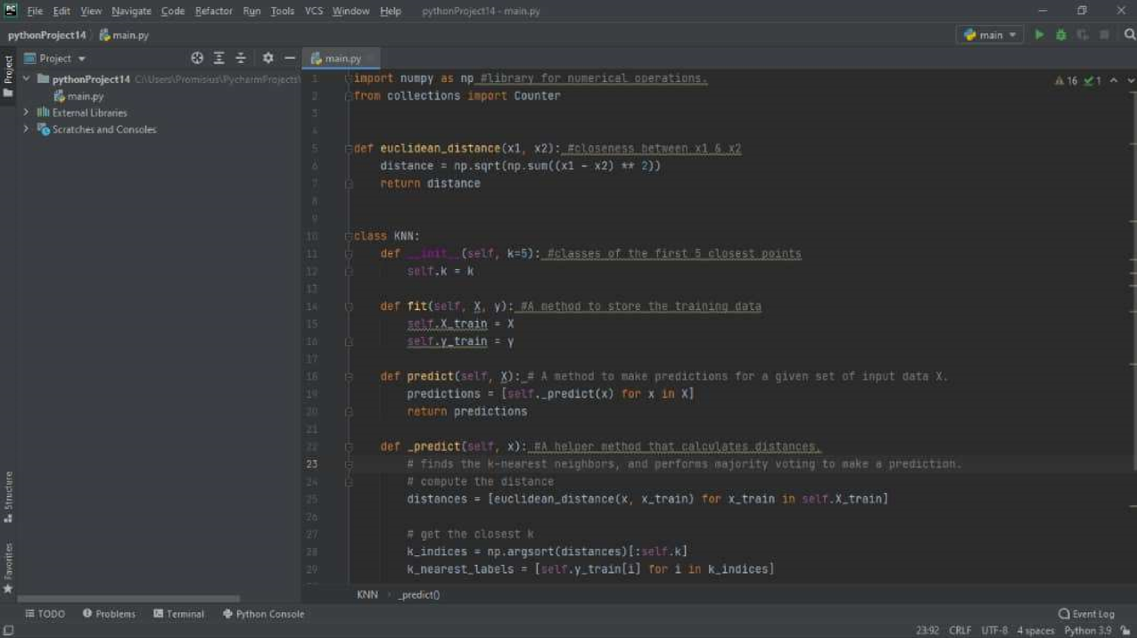



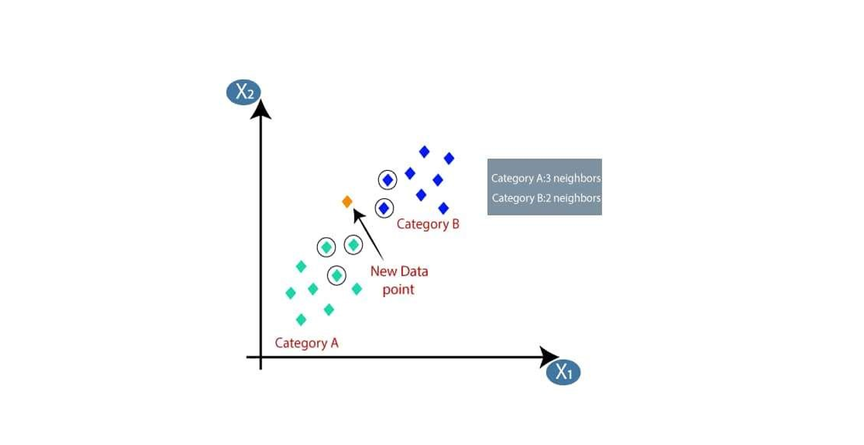

**6. Conclusion**

In conclusion, visual recognition is a crucial aspect of AI that aims to enable machines to understand the visual world. The CNN, Random Forest, SVM, and KNN algorithms discussed in this report each offer unique features and advantages for visual recognition tasks.

1. CNNs are effective in image classification, object detection, facial recognition, and image segmentation due to their ability to automatically extract relevant features from visual data.
2. Random Forests are robust against overfitting, handle high-dimensional data well, and identify informative features from large datasets, making them valuable in visual recognition tasks.
3. SVMs excel in high-dimensional datasets, find optimal decision boundaries, and offer versatility in handling complex visual data.
4. KNN is a non-parametric, supervised learning classifier that relies on proximity to make accurate classifications, making it suitable for face recognition and classification tasks.

Understanding the characteristics and applications of these algorithms is essential for developing effective visual recognition systems and advancing the field of AI. However, it is important to consider the specific requirements, limitations, and challenges associated with each algorithm when selecting the most appropriate approach for a given visual recognition problem.